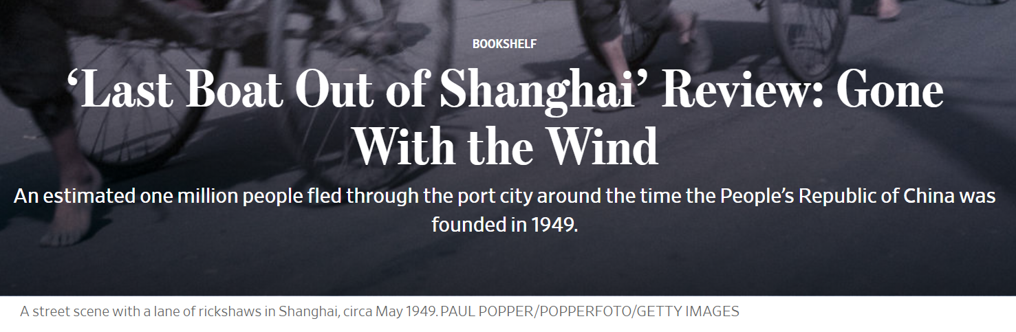
By
Jeffrey N. Wasserstrom
Jan. 18, 2019 9:43 a.m. ET
When it became clear, in the late 1940s, that Mao Zedong’s Communist forces would defeat Chiang Kai-shek’s Nationalist forces, more than a few Chinese residents of Shanghai greeted this news with joy and looked forward to a break from rule by a corrupt, autocratic government beholden to the United States. By contrast many foreigners in the city—European and American merchants and missionary families had been there since the mid-1800s—viewed the prospect of Communist Party rule with alarm. So, too, did many local Chinese, especially those of middling and higher social status.
I often teach a class called “Old Shanghai in Fact and Fiction.” Among the books we read in it is a 1993 memoir called “Tracing It Home” by Lynn Pan, a gifted writer born not long before the events of May 1949, which mainland textbooks refer to as the city’s “liberation” and other works describe as a Communist takeover. Ms. Pan’s businessman father left Shanghai for Southeast Asia before 1949, and she and the rest of the family joined him there in the early 1950s. But the key passage from “Tracing It Home” comes as the author conjures up the cosmopolitan cultural aspects of the pre-1949 city. Ms. Pan notes that, when Mao’s troops marched into Shanghai, “they were showing Hamlet with Laurence Olivier” at the Capitol, one of the leading local cinemas, “and at the Grand, I Wonder Who’s Kissing Her Now.” And then she writes: “To leave or not to leave: everywhere there was talk of this, of whether the communists were the very devil or a change for the better. Those who spoke of departure and starting life anew in Hong Kong or America spoke in hushed voices—hushed because departure was at once like betrayal and surrender.”

LAST BOAT OUT OF SHANGHAI
By Helen Zia
Ballantine, 499 pages, $28
If you had asked me a decade ago—even a month ago—what to read to get an evocative sense of the dilemma faced by Chinese families who fled Shanghai, I would have handed you Ms. Pan’s memoir. Now, having finished Helen Zia’s beautifully crafted, carefully researched “Last Boat Out of Shanghai: The Epic Story of the Chinese Who Fled Mao’s Revolution,” I might have to think twice. For, among other things, Ms. Zia lets us eavesdrop on the conversations in “hushed voices” of several people whose childhoods are brought vividly to life.
An estimated one million people fled through Shanghai around the time the People’s Republic of China was founded in 1949. Ms. Zia, a journalist and activist whose mother was a first-generation immigrant from Shanghai, focuses on four individuals whose lives were turned upside down by the same midcentury series of events. She says she chose them after conducting preliminary interviews with some 100 people who were part of the massive and, until now, little-studied migration of Shanghai residents to other places. The author interviewed each subject at great length while also, where possible, talking to their spouses, children and friends. In addition, she perused archives and published texts in English, ranging from newspapers to works of scholarship and memoirs, in order to help put the oral histories of her subjects into context.
One of the strengths of “Last Boat Out of Shanghai” is that each member of the central quartet comes across as a well-rounded individual. Just to give a sense of the variation among them, however, they can be described in this way:
Bing Woo, born into a family that quickly fell on hard times, was given or sold (the details are murky) to first one and then another couple. She spent the bulk of her childhood in a role midway between that of an adopted daughter and a family servant, helping tend to smaller children. She also spent many years imagining that somehow she might be reunited with her birth parents, before leaving their world definitively behind aboard the final ship of 1949 to sail from Shanghai to San Francisco. In a lovely bit of imagery, Ms. Zia writes of Bing knowing from a young age that she would likely never see her father again, yet being unable to “extinguish the small pilot light in her heart” that kept alive an unrealistic hope that she might.
Annuo Liu was dreamy, liked escaping from daily life via reading, and was driven for much of her life by a desire to prove that her father, a Nationalist Party official, was wrong to think she could never amount to anything. Ms. Zia writes that, after her family left Shanghai for Taiwan ahead of the Communist forces’ arrival, Annuo became enthralled by Margaret Mitchell’s “Gone With the Wind,” which was a hit in Chinese translation, feeling “a connection to the central character, a haughty young woman on the losing side of the American Civil War.”
Benny Pan (no relation to Lynn Pan), who came from the most privileged background of the four, went through a dramatic spiritual transformation in his late teens, after the father he admired and strove to emulate was imprisoned as a war criminal, and the mother he adored left the family to live with her husband’s former bodyguard. “At the soft edge of dawn,” Ms. Zia writes, to capture his mood in 1948, as a student at the Anglican college in Shanghai, “Benny lay under the covers of his St. John’s University dormitory room, watching as the darkness faded into the first rays of the morning light.” He treasured the “quiet stillness” for providing a “momentary reprieve from the daily anxiety” generated by news that his father was a “traitor to the Chinese people.” His family had begun its “free fall into calamity.”
Finally, Ho Chow, a studious and determined figure, moved to Ann Arbor, Mich., in 1947 to do graduate work in engineering, only to discover that life in America was filled with obstacles—from racial prejudices to shifting Cold War-era political winds—that he had not anticipated. Ms. Zia writes of Ho and other exiles in the United States meeting in “private, worried huddles” in 1950, concerned that if they defended Communist China, “they might be labeled as pro-Communist and face arrest and imprisonment by the U.S. government,” but “if they criticized the Communists, their families in China could be harmed in retaliation.”
For all the ways these men and women differ, they do have much in common. First, all are ethnically Chinese: This is worth noting, given that many occupants of berths on the literal last boat with Bing were foreigners or, like her adoptive sister’s son, Eurasians. Second, they all spent much of their childhood in “Old Shanghai”—the term now commonly used for the city when it was a treaty port that sprawled west from the Huangpu River. A third important similarity is that each refugee was part of a family of some means, or at least had ties to such a family. It was mostly men and women with resources who wanted to—and managed to—flee Shanghai when it was clear that the Communists would win the Civil War.
Of course, there’s one more thing Ms. Zia’s subjects have in common, right there in the book’s subtitle: They all left, eventually ending up in the United States, though in some cases after spending time in other locales.
Aside from an opening, midcentury vignette, “Last Boat Out of Shanghai” proceeds chronologically from 1937, when parts of the city first fell under Japanese control, through eight years of fighting between China and Japan (and four years of Civil War after that) to the founding of the People’s Republic of China in 1949. Ms. Zia moves toward that dividing point at a deliberate but never dull pace, weaving together episodes relating to first one central character and then another, in a manner that provides the reading pleasures of a well-turned set of interconnected short stories. After reaching the moment in May 1949 when the titular last ship out sails, the book picks up speed, moving at an accelerated pace toward the present.
“Last Boat Out of Shanghai” is an engaging work of high-quality popular history. It has things to offer not just to general readers with little knowledge about the city’s intriguing past, but even to specialists who may begin it in a suspicious state of mind: I plead guilty here, since the book’s lack of Chinese-language sources could have led to a blinkered account. While Ms. Zia enlisted translators, further use might have added richness to sections of the book that deal with topics about which the English language records are minimal. And though the author consulted many scholarly books, she overlooked some that would have been helpful to her, such as Sherman Cochran and Andrew Hsieh’s “The Lius of Shanghai” (2013), which follows members of a local family around the world—and across the 1949 divide—via letters home from students studying abroad.

These are relatively small complaints, however, in light of how much Ms. Zia does well. Most strikingly, the author tells stories of great specificity while simultaneously emphasizing general themes of migration and exile, which she clearly feels have contemporary relevance. The migrants in Ms. Zia’s story are empathetic and varied individuals, and the Shanghai they left behind is presented, aptly, as a city shaped by previous migratory waves.
Shanghai, after all, was never a colony of a single foreign power (à la Macau and Hong Kong) but instead was divided, from the early 1840s to the early 1940s, into a Chinese-controlled district and two separate foreign-run enclaves. Some accounts portray Shanghai’s foreign community as one made up primarily of people with ties to England, France and America. Yet by the mid-1930s, in addition to large numbers of Japanese residents, there were more White Russian refugees than Britons and Americans combined. Shanghai was also one of the last places to accept Jews escaping from Nazi Germany. It was a remarkable place—and, then, it was some place else.
“Last Boat Out of Shanghai” is so good I’ll certainly need to add it the syllabus for my class. That means something else will have to go—or my students will simply have 400 more pages of fascinating reading.
—Mr. Wasserstrom is the co-author of “China in the 21st Century: What Everyone Needs to Know,” an updated third edition of which was published last year.

